Lab Assignment 4

Name- Keshav Garg

Id- 2018UCP1674

Q1.

CREATE TABLE bookstore (bookid INTEGER, Yaer INTEGER, month VARCHAR(25), volume INTEGER, author VARCHAR(25),price INTEGER);

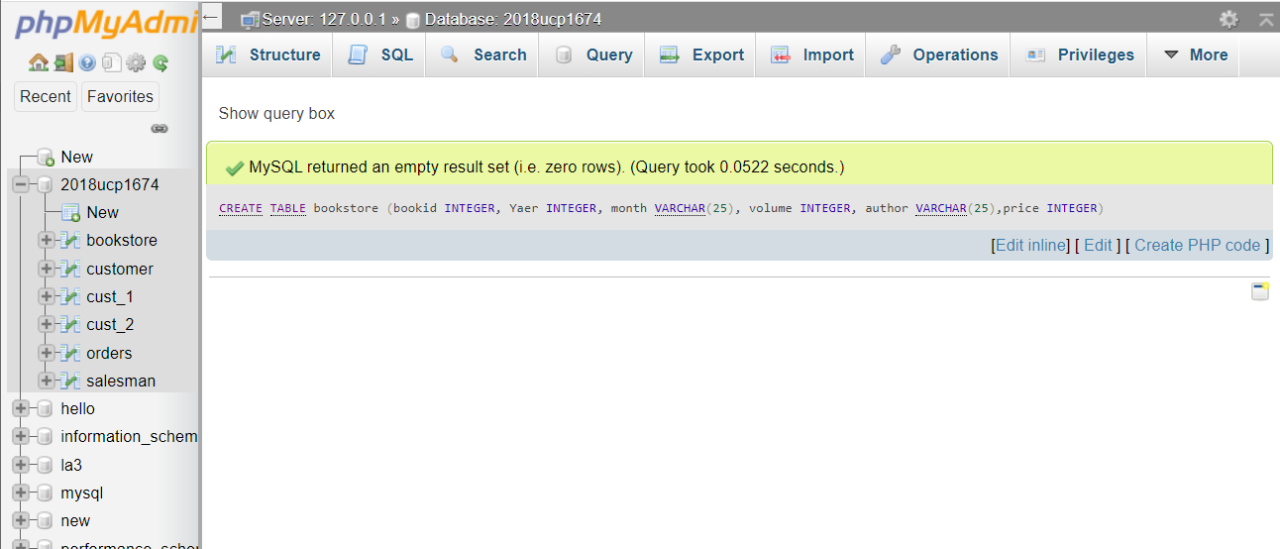

Q2.

ALTER TABLE bookstore MODIFY price int NOT NULL;

ALTER TABLE bookstore ADD CONSTRAINT pk_bookstore PRIMARY KEY (bookid);

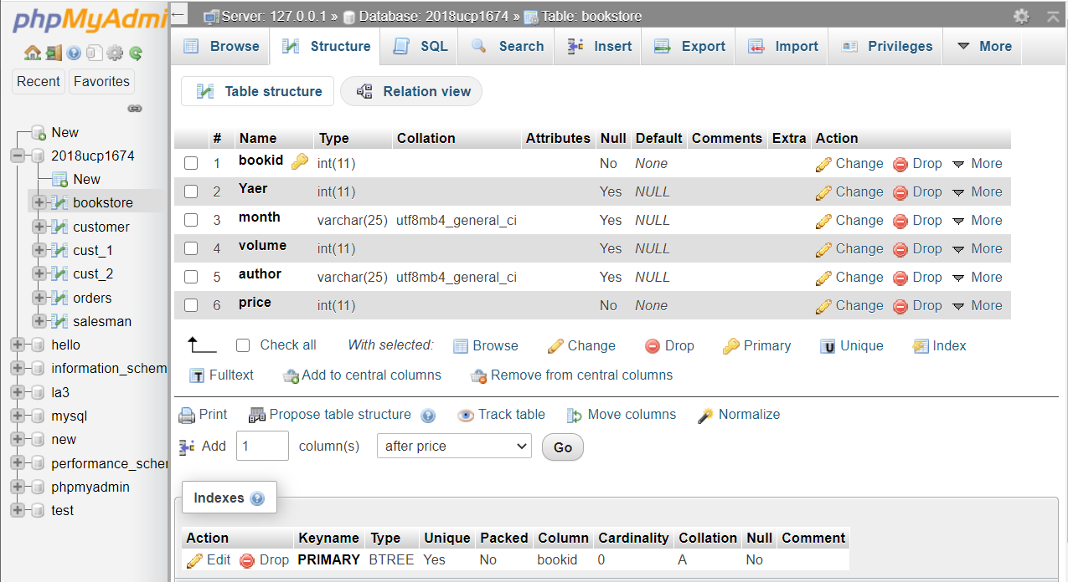

Q3.

INSERT INTO bookstore VALUES (1,2020,'January',2,'Ram Kumar',1000),(2,2009,'February',4,'Danish Kumar',4000),(3,2019,'March',6,'Ram Kumar',2000),(4,2018,'April',2,'Danish Kumar',5000),(5,2012,'May',4,'Ram Kumar',1000);

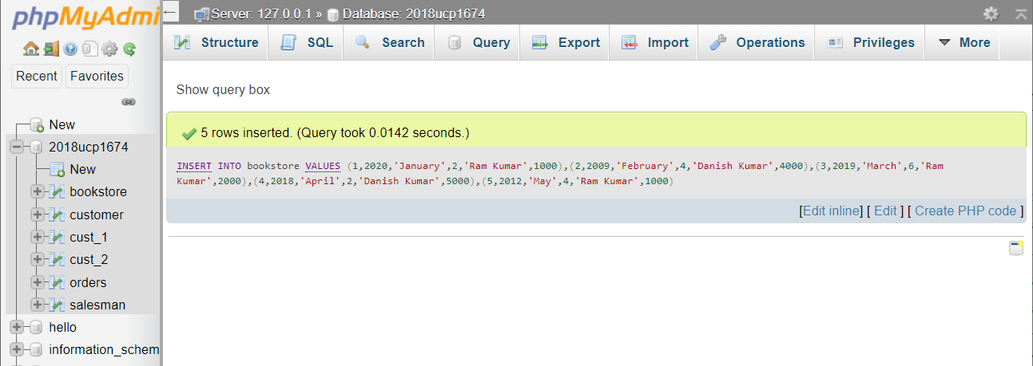

Q4.

DELETE FROM bookstore LIMIT 2;

First 2 rows of records have been deleted with bookid(1,2)

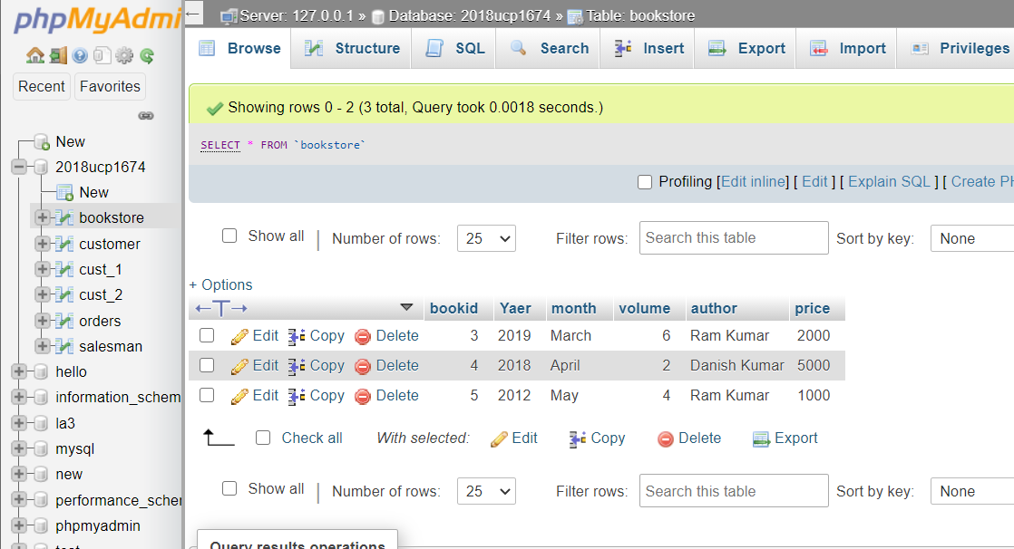

Q5.

UPDATE bookstore SET bookstore.Yaer =2020 WHERE bookstore.author='Danish Kumar';

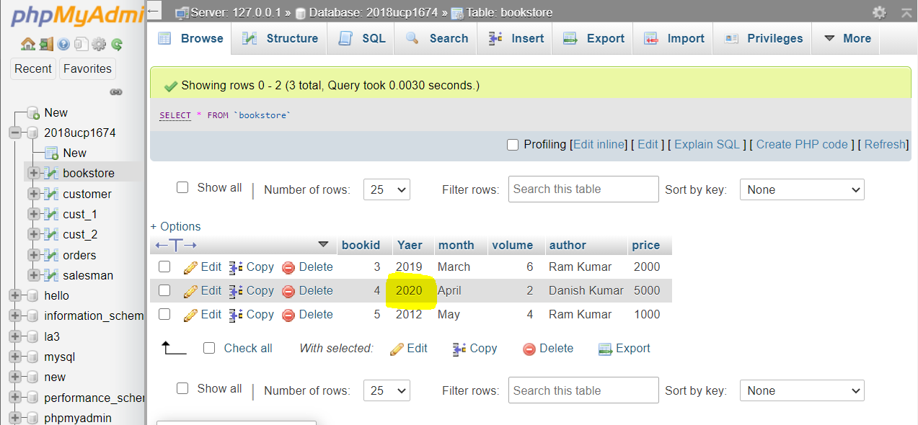

Q6.

ALTER TABLE bookstore MODIFY COLUMN price float;

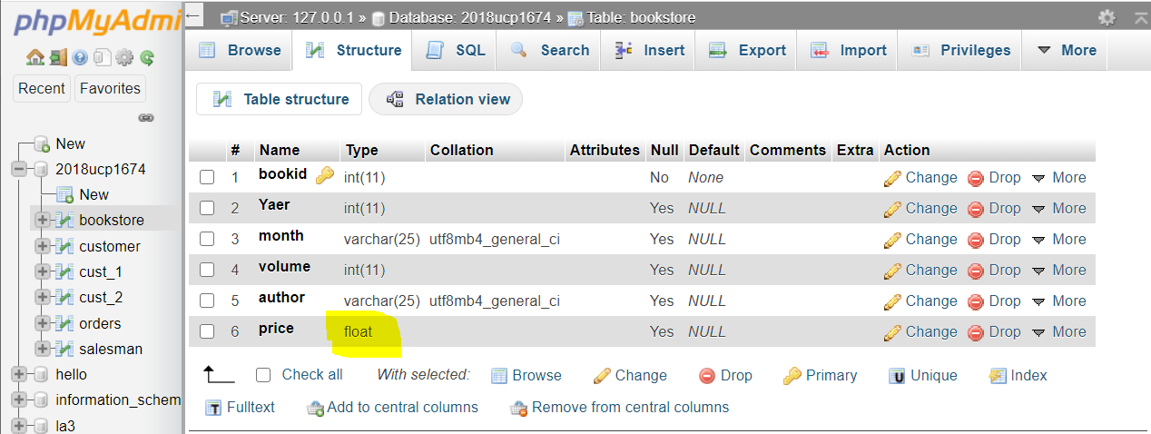

Q7.

ALTER TABLE bookstore ADD COLUMN publisher VARCHAR(25) NOT NULL;

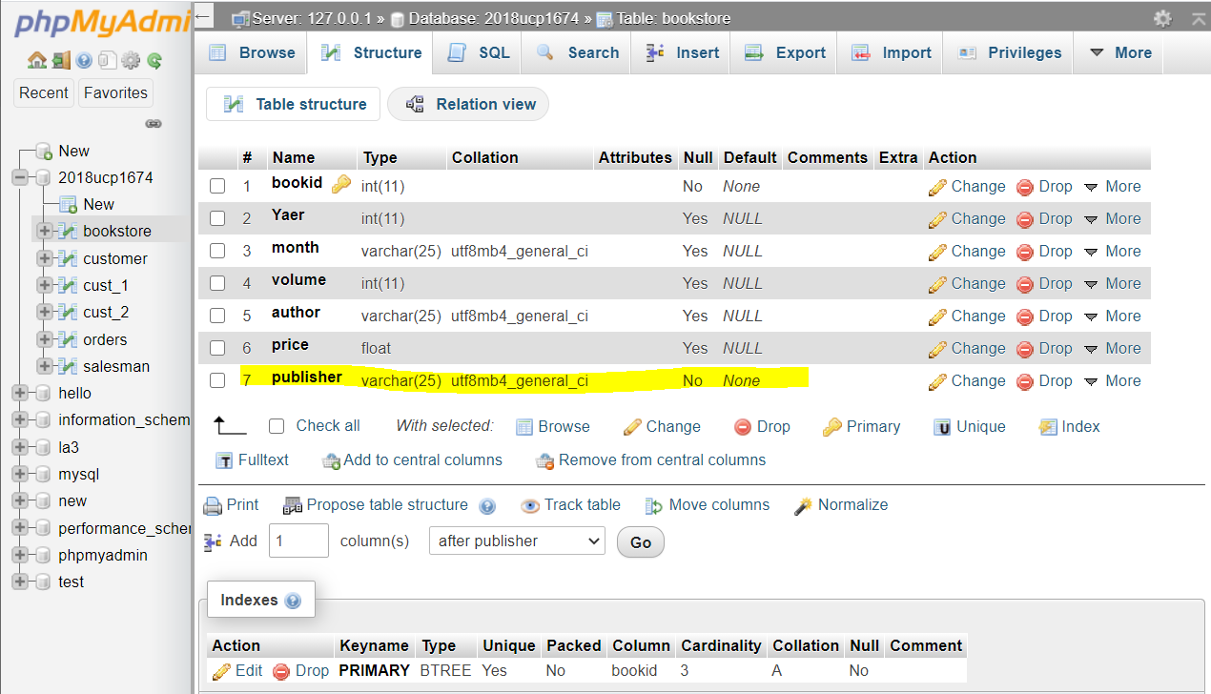

Q8.

SELECT month, count(*) FROM bookstore GROUP BY month ORDER BY COUNT(*) ASC;

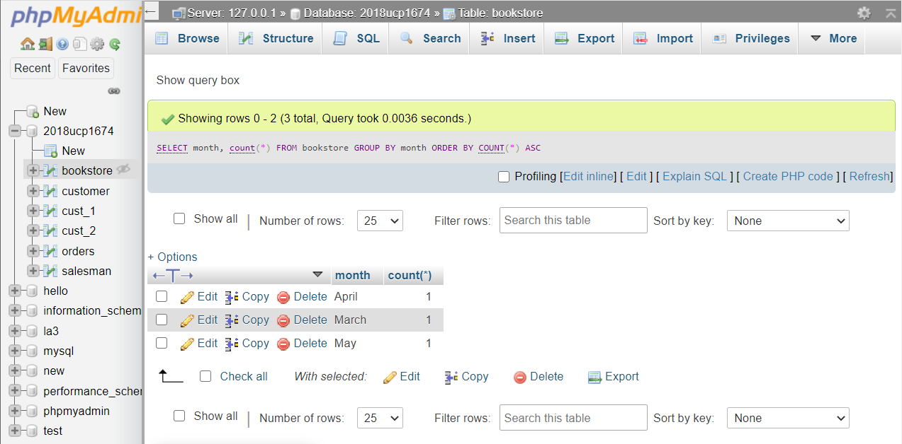

Q9.

CREATE INDEX idx_ym ON bookstore(yaer, month);

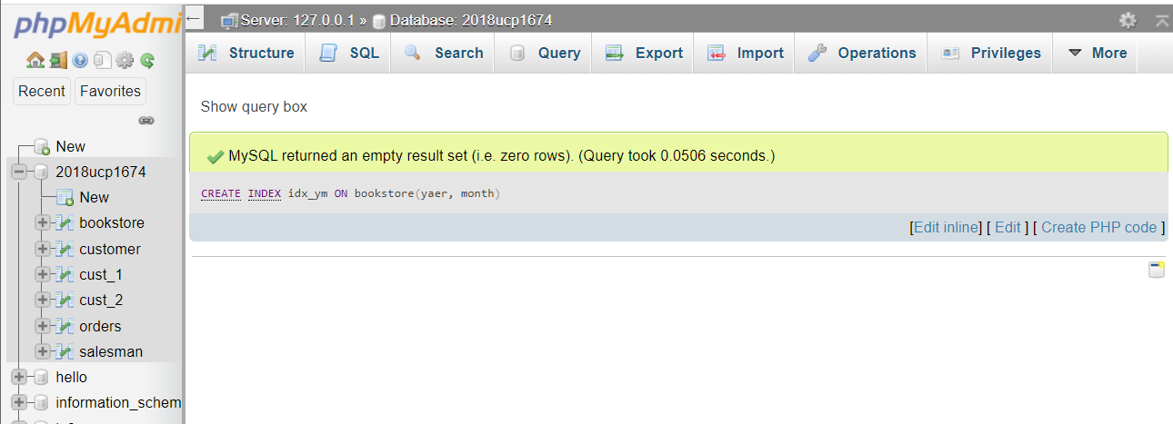

Q10.

TRUNCATE TABLE bookstore;

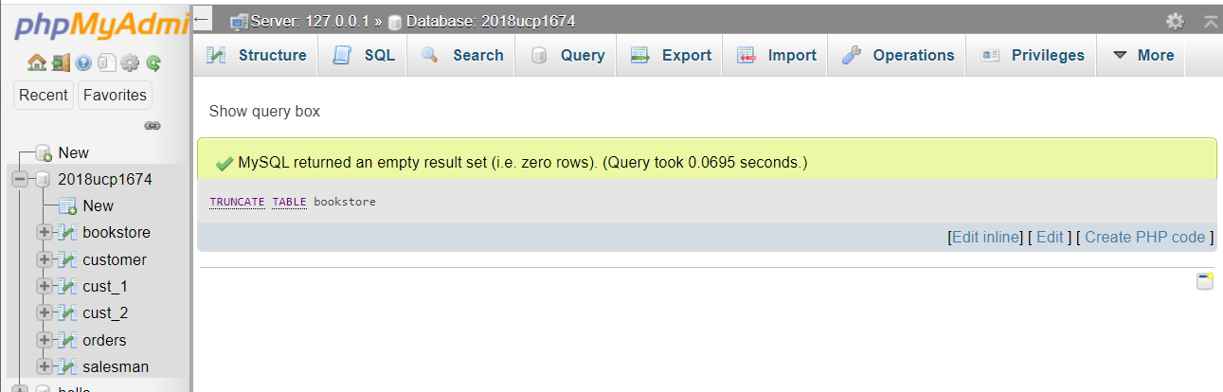

-------END-------